
MANEA SENIOR COLLEGE

2B PHYSICS PRACTICAL EXAMINATION

Student’s Name: ANSWER KEY

Student Area: ___________________

TIME ALLOWED FOR THIS PAPER:
Working time for paper: 1 hour 40 minutes

MATERIAL REQUIRED/RECOMMENDED FOR THIS PAPER

TO BE PROVIDED BY THE SUPERVISOR

This Question/Answer Booklet comprising 8 pages.
Physics: Formulae and Constants Sheet (back of this Question/Answer Booklet).

TO BE PROVIDED BY THE CANDIDATE

Standard Items: Pens, pencils, eraser or correction fluid, ruler.

Special Items: MATHOMAT and/or Mathaid, compass, protractor, set square and calculators satisfying the conditions set by the Curriculum Council.

IMPORTANT NOTE TO CANDIDATES

No other items may be taken into the examination room.

It is your responsibility to ensure that you do not have any unauthorised notes or other items of a non-personal nature in the examination room. If you have any unauthorised material with you hand it to the supervisor BEFORE reading any further.

STATION | TOTAL MARK | MARK OBTAINED
1 | 10
2 | 10
3 | 14
4 | 11
5 | 10
TOTAL | 55

STATION ONE: (10 marks)
Parallel Circuit A = 100 Ω B = 50 Ω
- Set up a parallel circuit with Resistors A and B and connect to the power pack set on 6 V.
- Measure and record the value of the potential difference across the power pack when the circuit is operating. Around 6 V (depends on quality of power packs) ( 1 mark)
- Measure and record the total current in the circuit. Around 0.18 A (depends on PD) ( 1 mark)
- Measure the potential different and current for each unknown resistor. Complete the table
(4 marks)
 | Resistor A | Resistor B
Current | Approx 0.06 | Approx 0.12
Potential difference | Approx 6 V  Similar to PD above | Approx 6 V  Similar to PD above

- Calculate the value of the resistor. Show all working. (2 marks)

Use 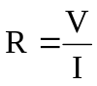  Shows working  Resistor A: 100 Ω | Use 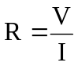  Shows working  Resistor B: 50 Ω

- Based on your understanding of circuit theory, do you think these values are approximately
correct? Fully explain using your understanding of circuit theory and any appropriate calculations.
(2 marks)

Various possible answers but must show an understanding of theory e.g.

    - In parallel, PD same value.
    - R_{A} is twice as much as R_{B} so half current in R_{A} to R_{B}
    - I_{T} = I_{A} + I_{B}
    - R_{T} = (100⁻¹ + 50⁻¹)⁻¹ = 33.33 Ω
V_{T} = R_{T} x I_{T}
= 33.33 x 0.18
= 6 V
= approx same as PD value

STATION TWO: (10 marks)

Series Circuits C = 20 Ω D = 100 Ω
- Set up a series circuit with Resistors C and D and the power pack set on 6 V.
- Measure and record the value of the potential difference across the power pack when the circuit is operational. Approximately 6 V ( 1 mark)
- Measure and record the total current of the circuit. Approximately 0.05 A ( 1 mark)
- Measure the current and potential different for each unknown resistor. Complete the table
(4 marks)

 | Resistor C | Resistor D
Current | 0.05 A | 0.05 A  (same as resistor C)
Potential difference | Approx 1.0 V | Approx 5 V

- Calculate the value of the resistor. Show all working. (2 marks)

Use 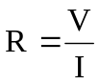  Show working  Resistor B: 20 Ω | Use 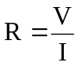  Show working  Resistor C: 100 Ω

- Based on your understanding of circuit theory, do you think these values are approximately correct? Fully explain using your understanding of circuit theory and any appropriate calculations.
(2 marks)

Various possible answers but must show an understanding of theory e.g.

- In series, I is same value throughout circuit
- R_{D} is 5 times as large as R_{C} so PD of R_{D} should be 5 times as large.
- PD_{T} = PD_{C} + PD_{D}

STATION THREE: (14 marks)
A. Heating a liquid
In a university laboratory, a student was trying to determine the melting point of 10.0 g of solid paradichlorobenzene (moth repellent). He used a test tube of paradichlorobenzene which had previously had a thermometer placed inside it when liquid and had been left to set and reach room temperature as a solid. The student had then placed the test tube in a clamp attached to a retort stand and had heated the paradichlorobenzene measuring the temperature every half minute. His results are shown below.

Time  (min) | 0 | 0.5 | 1 | 1.5 | 2 | 2.5 | 3 | 3.5 | 4 | 4.5 | 5 | 5.5 | 6 | 6.5 | 7 | 7.5 | 8 | 8.5 | 9 | 9.5 | 10
Temp  ⁰C | 18 | 20 | 24 | 28 | 30 | 33 | 35 | 39 | 43 | 45 | 48 | 50 | 53 | 53 | 53 | 53 | 53 | 61 | 70 | 77 | 84

- Draw a graph which will show the heating curve of the paradichlorobenzene. (4 marks)

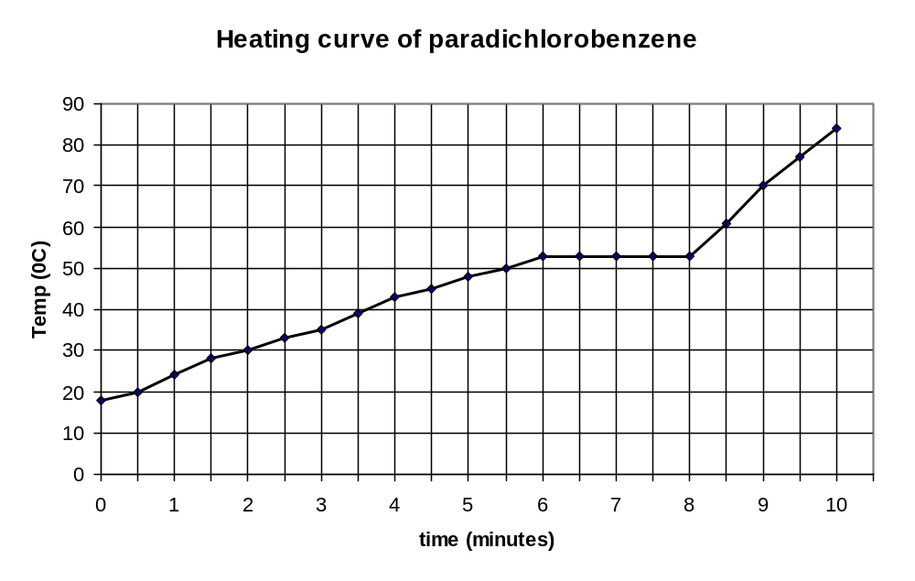
Marks
Axis – 1
Labels – 1
Points – 1
Line – 1

From the graph, determine the melting point of the paradichlorobenzene. 53 ⁰C (1 mark)

- What effect do you think using 20.0 g of paradichlorobenzene would have had on the shape of the heating curve? Explain. (2 marks)

The general shape would not change as the melting point is the same.

The length of the horizontal section would increase as there is more substance to change from solid to liquid.

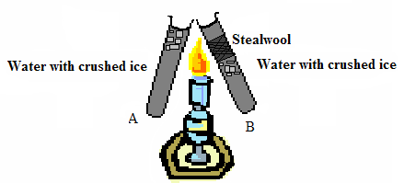
Heat Transfer
- The diagram show two test tubes with ice being heated. In A, the ice is floating on the top of the water. In B, the ice is held halfway down by some steel wool.

  - In which test tube does the ice melt the slowest? B (1 mark)
  - Explain why the ice melts the slowest. (3 marks}
Main idea is that as heating from the top, convection currents will not be set up.

Ice at top is in contact with heat so melts quickly.

Ice below steel wool remains frozen longer as it takes time for the heat to travel downwards to the ice as heat rises.

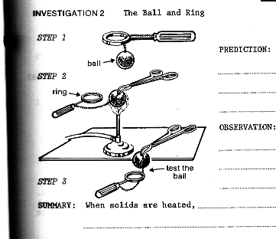
Expansion and contraction
- The picture on the right shows an experiment which was demonstrated to you earlier this year.

Initially the ball passes through the ring. The ball is then heated.

Fully explain if the ball will or will not pass through the ring.
(3 marks)

Main idea is that as metals are heated they expand.

The ball will not pass through the ring.

As ball is heated, kinetic energy is added to the metal particles.
The particles increase their vibration, move further apart and the ball expands.
As it is now larger, it doesn’t fit through the ring.

STATION FOUR: (11 marks)
A student has been given two different electrical component. He sets up a circuit and takes the following readings. He then graphs the potential difference against the current for the two devices.

Potential Difference | Current in Component One | Current in Component Two
0 | 0 | 0
2 | 4 | 4
4 | 8.1 | 7.9
6 | 11.9 | 10.8
8 | 16 | 12.9
10 | 19.9 | 14.8
12 | 24.1 | 16

- On the graph on the next page, graph the data above (PD on x-axis). (4 marks)
Need to have independent variable on x-axis
- What do you think the purpose of this investigation was? (1 marks)

The purpose was to compare the relationship between current and potential difference in two components (better answers will include - one that was ohmic and one non-ohmic)

- Calculate the gradient of Component One. (2 marks)
Should take two points on the line of best fit e.g. from my graph (10, 20) and (5, 10)
Gradient = 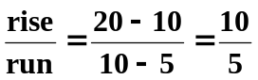
Gradient = 2

But, resistance is 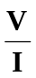 which is inverse of the graph so the resistance is 2⁻¹ = 0.5

- What does this value represent? Inverse of Resistance or resistance (depends on graph) (1 mark)
- (i) What does the graph show about the relationship between potential difference and current in
Component Two? (2 marks)

It is not directly proportional

As the potential difference increases, the current increases but at a slower rate.

- What name is given to these types of components?
Non-ohmic resistors (1 mark)

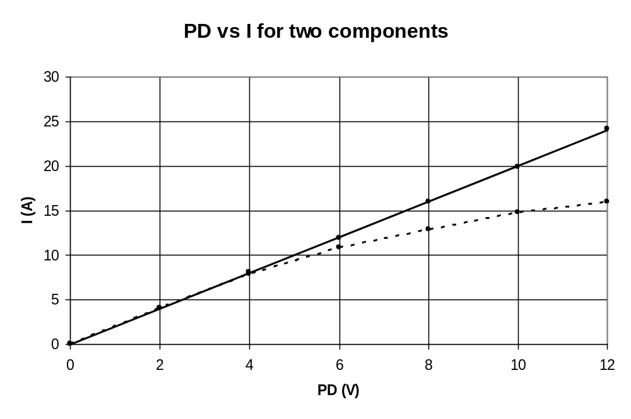
Legend:
Component One
Component Two
Marks
Axis – 1
Labels – 1
Points – 1
Line – 1

STATION FIVE: (10 marks)

Temperature of the bunsen flame
A student wanted to find the temperature of the bunsen flame in his school laboratory. He ties a length of iron wire around an iron cube. He heated the iron cube for 5 minutes in the flame and transferred the iron cube into water in the calorimeter. The water was stirred and the final temperature measured. He repeats the experiment several times and the average values are recorded below.

The student collected the following averaged data.

Type of metal cube used: iron
Temperature of water at start of experiment: 19⁰ C
Temperature of water at end of experiment: 41⁰ C
Mass of iron cube: 73.5 g
Mass of iron wire: 3.50 g mass of iron = 77.0 g = 0.077 kg
Mass of copper calorimeter 44 g
Mass of copper calorimeter and water 144 g mass of water = 0.144 – 0.044 = 0.10 kg

From the data, determine the temperature of the bunsen flame. (6 marks)

Heat lost = heat gained
mcΔT_{iron} = mcΔT _{water} + mcΔT _{copper}
0.077 x 440 x (T_{f} - 41 ) = [(0.10 x 4180 x (41 – 19) + (0.044 x 390 x (41 – 19)]
33.88T_{f} – 1389.08 = 9196 + 377.52
33.88T_{f} = 1389.08 + 9196 + 377.52
33.88T_{f} = 10962.6
T_{f} = 323.6 ⁰C

Measuring Electrical Energy
Electrical energy is used to heat 0.15 kg of water at 20 ⁰C. The heating element is left on for eight minutes while the potential difference was 5.5 V and the current was 1.8 A. What was the final temperature of the water? (4 marks)

W = VIt
t = 8 x 60
480 s VIt = mcΔT
and 5.5 x 1.8 x 420 = 0.15 x 4180 x ΔT
Q = mcΔT 4158 = 627ΔT
ΔT = 6.63
Also as originally on 20 ⁰C, final temp is 26.63 ⁰C
W = Q as both energy

